Malwa Enclave By Satya Group

Project Details:
Malwa County: Your Dream Home Awaits in Indore
Imagine coming home to a place where your kids can safely ride their bikes, where you can unwind at a world-class clubhouse after work, and where everything you need is just minutes away. That's Malwa County by Satya Group – a beautifully planned 110-acre community on AB Bypass Road that's already home to over 450 happy families.

Why Families Love Living Here
Perfect Location, Perfect Life
- Your morning school run? Just 5 minutes to top schools like Emerald Heights and GD Goenka
- Medical emergencies? Apollo and Medanta hospitals are only 20 minutes away
- Weekend getaways? The airport and Ujjain are just 30-40 minutes down the road
- Daily commute? You're right on AB Bypass Road with excellent connectivity
Ready to Move In
- No more waiting! Plots (starting at 1300 sq.ft.) and luxury villas are ready for immediate possession
- Wide 40-foot internal roads mean no traffic jams within the community
- Getting a home loan? Banks offer up to 80% financing – we'll help you through the process
Your Home, Your Way
Choose What Fits Your Family:
- Ready Plots – Design your dream home exactly how you want it
- Luxury Villas – Move in tomorrow if you'd like
- Modern Apartments – Malwa Jewels and Malwa Heights offer contemporary living
- Malwa Enclave – Mix of plots and villas for varied preferences
Live the Resort Lifestyle Every Day
55,000 Sq.Ft. Clubhouse That's Actually Amazing:
- Swimming pool where your kids will spend every summer evening
- Fully equipped gym (no more expensive memberships!)
- Indoor badminton, table tennis, and pool tables for family tournaments
- Pickleball, tennis, volleyball, and basketball courts – something for everyone
Community Spaces That Bring Neighbors Together:
- Amphitheater for cultural events and celebrations
- Jogging and cycling tracks for your morning routine
- Beautiful gardens where kids play and adults chat
- Kids' indoor play zone for those rainy days
- Guest rooms for when family visits
Everything You Need on Your Doorstep:
- Temple for daily prayers and festivals
- Nursing home for healthcare needs
- School within the community (imagine the short school run!)
- Convenient store for last-minute essentials
Note: All details mentioned are based on project information. We recommend visiting the site and speaking with the Roots & Roofs team to get the complete picture and verify all specifics. After all, this is where your family will create their most precious memories.
Your Complete Neighborhood
What You Need | Where It Is
Schools | Emerald Heights, GD Goenka (5 mins)
Healthcare | Apollo, Medanta Hospitals (20 mins)
Transportation | Mangliya Railway Station (nearby)
Travel | Indore Airport (30-40 mins)
Shopping & Entertainment | City centers easily accessible
About Satya Group – People You Can Trust
Transparency First:
- RERA Registration: P-SWR-25-5860 ✅
- All approvals and documents available for review
What This Really Means for Your Family
More Than Just a Home: This isn't just about buying property – it's about choosing a lifestyle. Picture Saturday mornings at the tennis court, evening walks through landscaped gardens, kids making lifelong friends in a safe environment, and having everything from schools to hospitals just minutes away.
Smart Investment: With Indore growing rapidly and AB Bypass Road becoming increasingly important, you're not just buying a home – you're investing in your family's future.
Peace of Mind: RERA-registered, bank-approved loans, ready possession, and a developer with a proven track record. We've taken care of the complicated stuff so you can focus on the fun part – planning your new life here.
Row House:
9 left
1281 sq. ft.
Construction area 1672 sq. ft.
Starting at 80 L ++
Pictures:
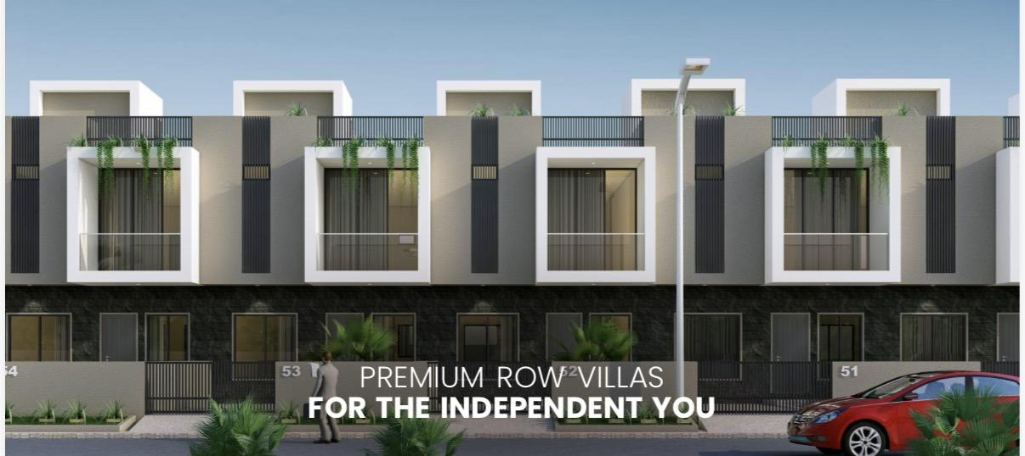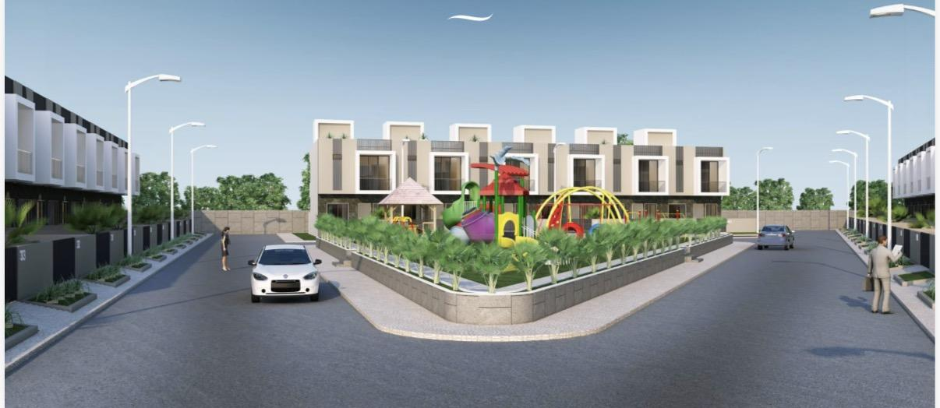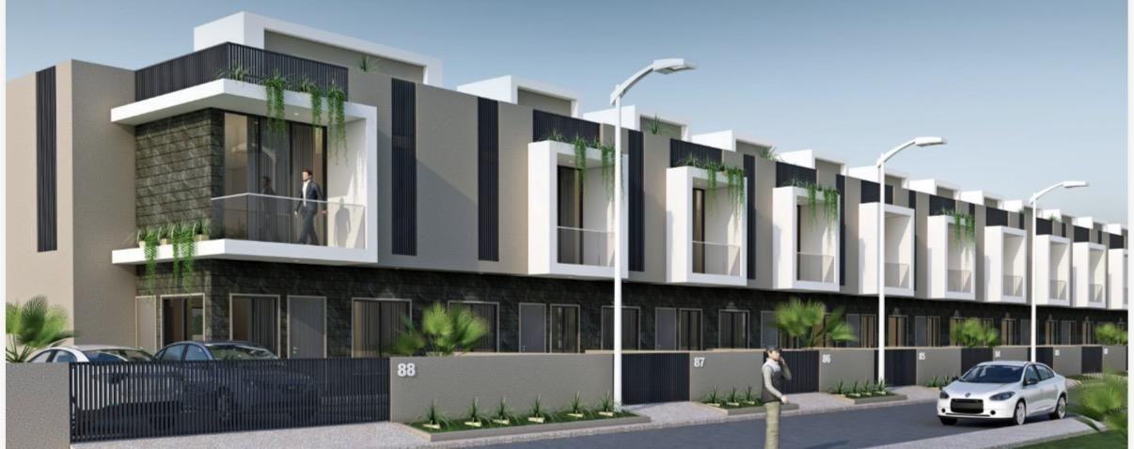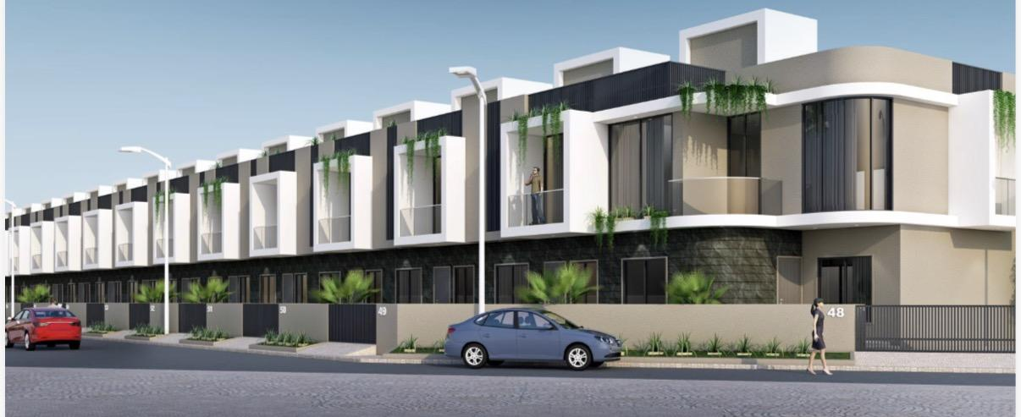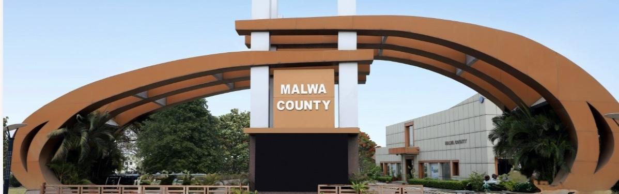
Site Plan:
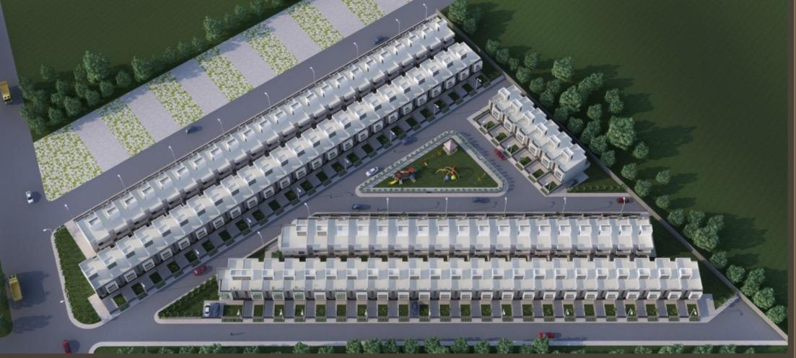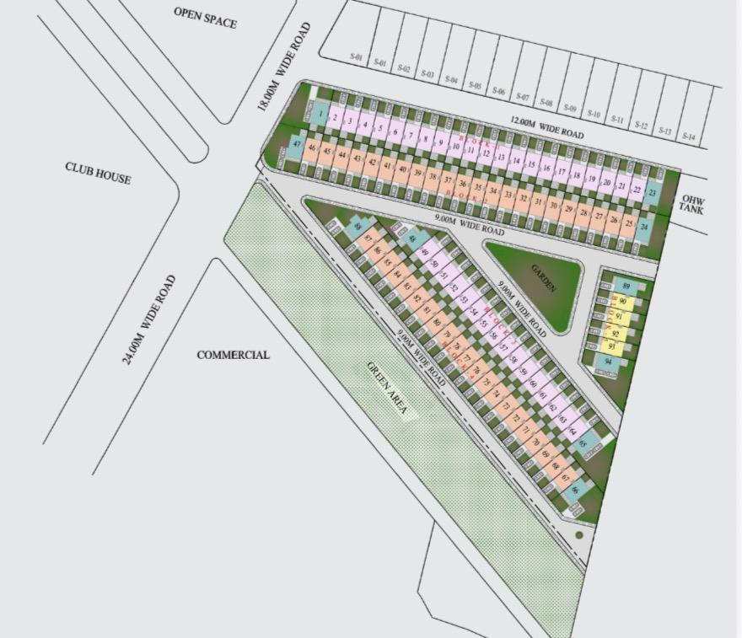
Floor Plan:
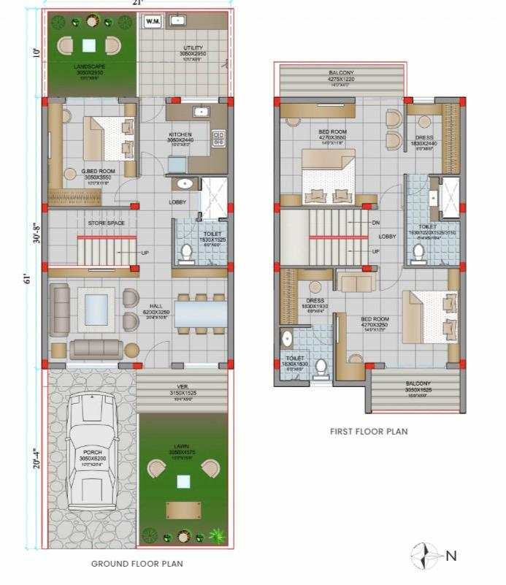
Location:
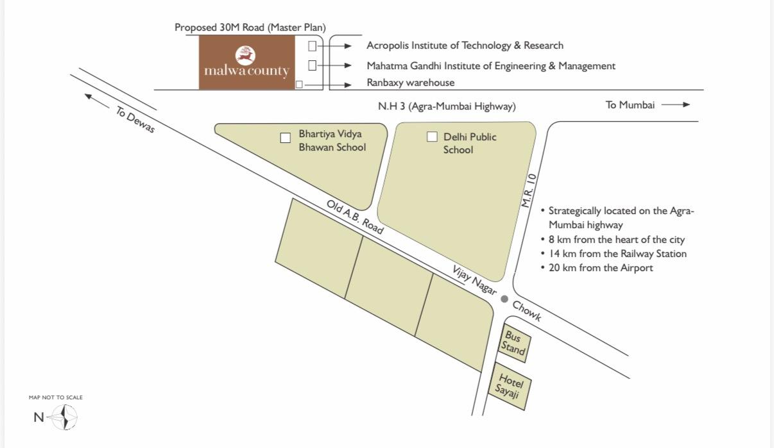
Specifications:
